**Project Document - Assignment – Online Bookstore**

|  |  |
| --- | --- |
| **Version Number** | **Author** |
|  |  |

**Part 1 - Fixing Existing Code Errors**

|  |  |  |
| --- | --- | --- |
| **Code Error** | **Description of Error** | **Fix Details** |
| **Null pointer when loading List<Book>** | **References are in lowercase when attributes listed in uppercase** | **Changed attributes to be lowercase to match naming convention** |
| **Import dispatchers.* was used** | **The package “dispatchers” does not exist** | **Comment out the import statement.** |
| **List<books>** | **“Books” does not exist** | **Changed “Books” to “Book”** |

**Part 2 – Reasons for using IDE**

|  |
| --- |
| 1. **NetBeans is created specifically for java.** 2. **NetBeans has native Database integration** 3. **NetBeans provides comprehensive support for JSP development** |

**Part 3 – Java EE Best Practices/Patterns- Summary (Research)**

(Include the references to your sources)

|  |
| --- |
| **ViewHelper**  **Template pattern**  **Command pattern** |

**Part 4 – Test Plans**

Document your test cases/test data /expected and actual outcomes using a desk-check format. Also include all screen shots of test run executions of all Use Cases here.

|  |  |  |  |
| --- | --- | --- | --- |
| Use Case | Test Data | Expected result | Actual result |
| View books | Book database | All books listed | All books listed |

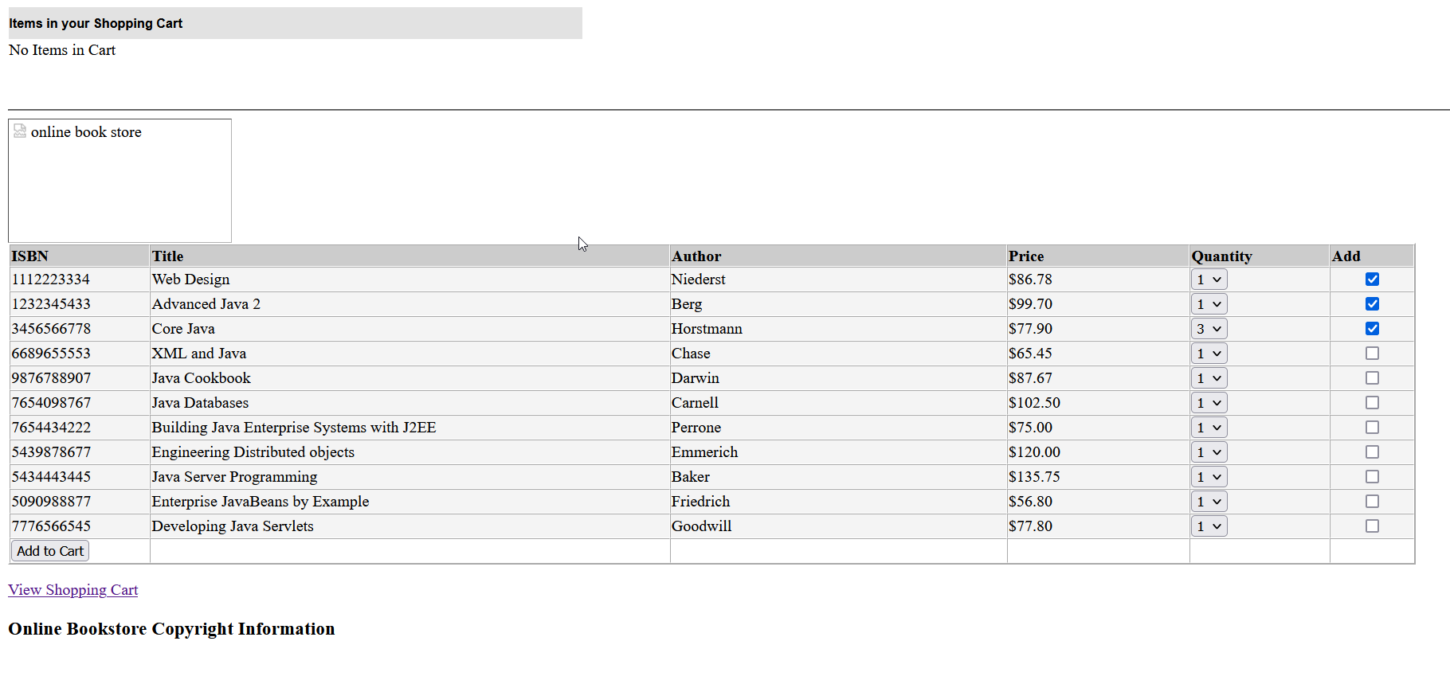

|  |  |  |  |
| --- | --- | --- | --- |
| Add books to cart | 1x Niederst, 1x Berg 3x Horstmann | Test data added to cart | Test data was added to cart |

|  |  |  |  |
| --- | --- | --- | --- |
| View shopping cart shows books | Books in cart from previous test | 1x Niederst, 1x Berg 3x Horstmann listed in cart | 1x Niederst, 1x Berg 3x Horstmann listed in cart |

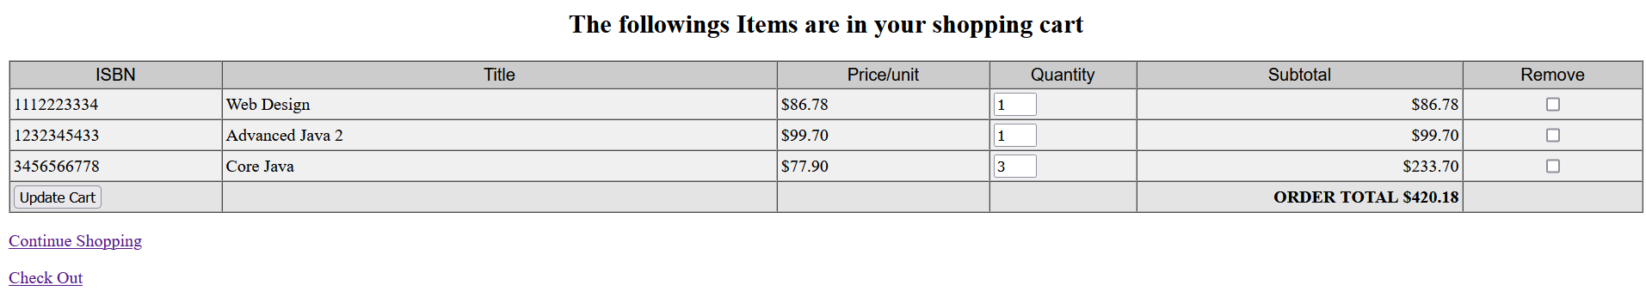

|  |  |  |  |
| --- | --- | --- | --- |
| remove book from cart/update cart button working | **Books in cart** | 1x Niederst, 3x Horstmann listed in cart/ 1xBerg removed | 1x Niederst, 3x Horstmann listed in cart/ 1xBerg removed |

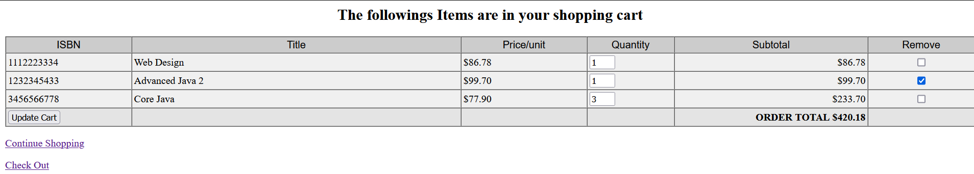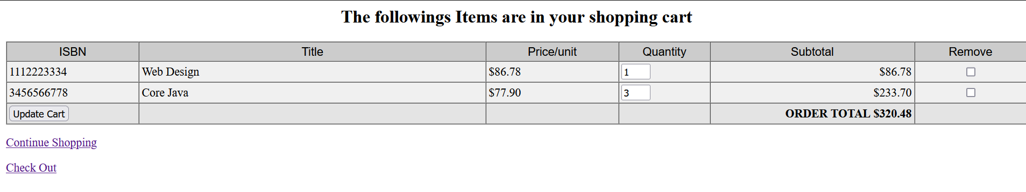

|  |  |  |  |
| --- | --- | --- | --- |
| **Continue shopping button works** | **Cart items** | **All cart items stay in cart and all books are listed** | **All cart items stay in cart and all books are listed** |

|  |  |  |  |
| --- | --- | --- | --- |
| Check out works | Items in shopping cart | Price of order matches check out order amount and checkout items match cart items | Price of order matches check out order amount and checkout items match cart items |

|  |  |  |  |
| --- | --- | --- | --- |
| **Submit button shows thankyou jsp** | **“check out” button then “Submit button”** | **Thankyou view is shown** | **Thankyou view is shown** |

|  |  |  |  |
| --- | --- | --- | --- |
| **Remove all items from cart and check out** | **No items in cart.** | **Error shown that no books are in the checkout** | **Error not shown, test Failed** |

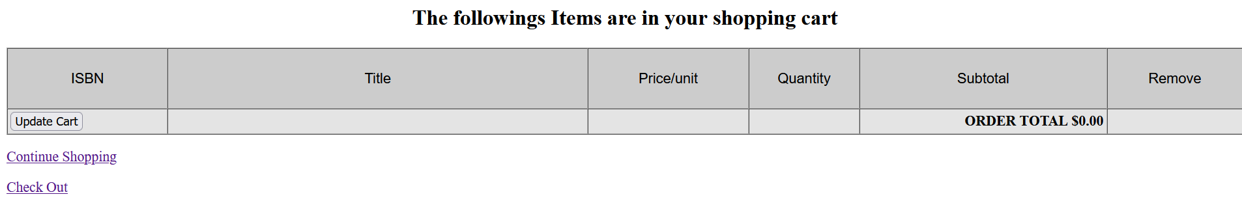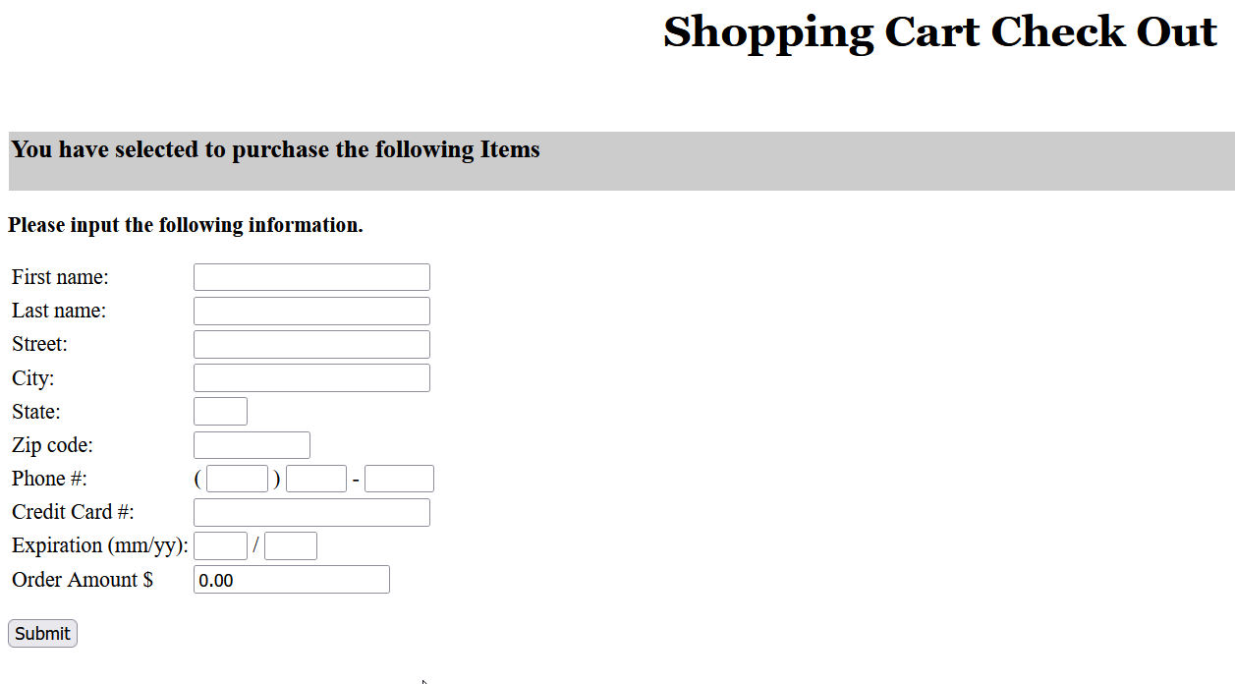

**Part 5 – java doc System Documentation**

Include the URL to access the above documentation of the re-engineered application

|  |
| --- |
| file:///C:/Users/Andre/Desktop/BookShop/dist/javadoc/index.html |

**Part 6 – Final UML Mode**

Include separate sequence diagrams for each of the Use Cases here.

